Assignment 2
CIPHERS
Basic Terminology:
- plaintext - the original message
- ciphertext - the coded message
- cipher- algorithm for transforming plaintext to ciphertext
- key - info used in cipher known only to sender/receiver
- encipher (encrypt) - converting plaintext to ciphertext
- decipher (decrypt) - recovering ciphertext from plaintext
- cryptography - study of encryption principles/methods
- cryptanalysis (codebreaking) - the study of principles/ methods of deciphering ciphertext without knowing key
- cryptology - the field of both cryptography and cryptanalysis

In cryptography, a cipher (or cypher) is an algorithm for performing encryption or decryption—a series of well-defined steps that can be followed as a procedure. An alternative, less common term is encipherment. To encipher or encode is to convert information into cipher or code.

'Cipher' is synonymous with 'code', as they are both a set of steps that encrypt a message. Codes generally substitute different length strings of characters in the output, while ciphers generally substitute the same number of characters as are input. There are exceptions and some cipher systems may use slightly more, or fewer, characters when output versus the number that were input.

Codes operated by substituting according to a large codebook which linked a random string of characters or numbers to a word or phrase. For example, "UQJHSE" could be the code for "Proceed to the following coordinates." When using a cipher the original information is known as plaintext, and the encrypted form as ciphertext. The ciphertext message contains all the information of the plaintext message, but is not in a format readable by a human or computer without the proper mechanism to decrypt it.

The operation of a cipher usually depends on a piece of auxiliary information, called a key (cryptovariable). The encrypting procedure is varied depending on the key, which changes the detailed operation of the algorithm. A key must be selected before using a cipher to encrypt a message. Without knowledge of the key, it should be extremely difficult, if not impossible, to decrypt the resulting ciphertext into readable plaintext.

Cryptography
- Symmetric / private key / single key
- Asymmetric / public-key / two - key

Symmetric Cryptography

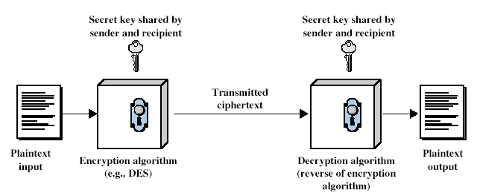
Asymmetric Cryptography
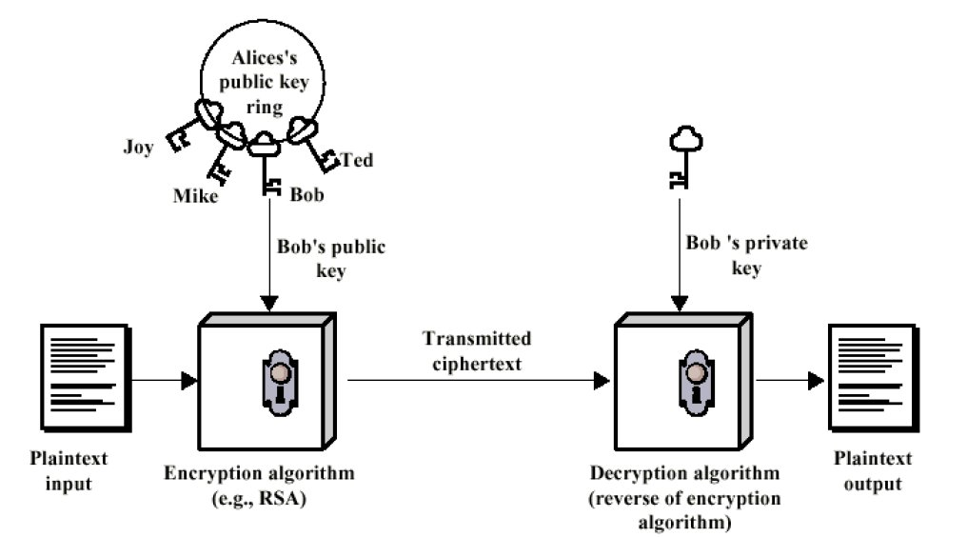

Caesar Cipher
- earliest known substitution cipher
- by Julius Caesar
- first attested use in military affairs
- replaces each letter by 3rd letter after it
- example:
meet me after the toga party
PHHW PH DIWHU WKH WRJD SDUWB
- can define transformation as:
a b c d e f g h i j k l m n o p q r s t u v w x y z
D E F G H I J K L M N O P Q R S T U V W X Y Z A B C
- mathematically give each letter a number
a b c d e f g h i j k l m
0 1 2 3 4 5 6 7 8 9 10 11 12
n o p q r s t u v w x y Z
13 14 15 16 17 18 19 20 21 22 23 24 25
- then have Caesar cipher as:
C = E(p ) = (p + k ) mod (26)
p = D(C) = (C – k ) mod (26)

Playfair Cipher
- not even the large number of keys in a monoalphabetic cipher provides security
- one approach to improving security was to encrypt multiple letters
- the Playfair Cipher is an example
- invented by Charles Wheatstone in 1854, but named after his friend Baron Playfair
- a 5X5 matrix of letters based on a keyword
(I and J aren’t distinguished)
- fill in letters of keyword (sans duplicates)
- fill rest of matrix with other letters
- eg. using the keyword MONARCHY
MONAR
CHYBD
EFGIK
LPQST
UVWXZ

Encrypting and Decrypting
- plaintext encrypted two letters at a time:
- each letter is replaced by the one in its row in the column of the other letter of the pair, eg. “hs" encrypts to "BP", and “ea" to "IM" or "JM" (as desired). Except when that doesn’t work!
- if a pair is a repeated letter, insert a filler like 'X', eg. "balloon" transformed to "ba lx lo on"
- if both letters fall in the same row, replace each with letter to right (wrapping back to start from end), eg. “ar" encrypts as "RM"
- if both letters fall in the same column, replace each with the letter below it (again wrapping to top from bottom), eg. “mu" encrypts to "CM"

Vigenère Cipher
- simplest polyalphabetic substitution cipher is the Vigenère Cipher
- effectively multiple caesar ciphers
- key is multiple letters long K = k1 k2 ... kd
- i^{th} letter specifies i^{th} alphabet to use
- use each alphabet in turn
- repeat from start after d letters in message
- decryption simply works in reverse
Example
- ey letter as a caesar cipher key
- encrypt the corresponding plaintext letter
- eg using keyword deceptive
key: deceptivedeceptivedeceptive
plaintext: wearediscoveredsaveyourself
ciphertext:ZICVTWQNGRZGVTWAVZHCQYGLMGJ
Steganography
- an alternative to encryption
- hides existence of message
- using only a subset of letters/words in a longer message marked in some way
- using invisible ink
- hiding in LSB in graphic image or sound file
has drawbacks
- high overhead to hide relatively few info bits

- Classification based on the type of input data:
- block ciphers, which encrypt block of data of fixed size, and
- stream ciphers, which encrypt continuous streams of data

Cryptographic Attacks
The basic intention of an attacker is to break a cryptosystem and to find the plaintext from the ciphertext. To obtain the plaintext, the attacker only needs to find out the secret decryption key, as the algorithm is already in public domain.
Hence, he applies maximum effort towards finding out the secret key used in the cryptosystem. Once the attacker is able to determine the key, the attacked system is considered as broken or compromised.
Based on the methodology used, attacks on cryptosystems are categorized as follows −
- Ciphertext Only Attacks (COA) − In this method, the attacker has access to a set of ciphertext(s). He does not have access to corresponding plaintext. COA is said to be successful when the corresponding plaintext can be determined from a given set of ciphertext. Occasionally, the encryption key can be determined from this attack. Modern cryptosystems are guarded against ciphertext-only attacks.
- Known Plaintext Attack (KPA) − In this method, the attacker knows the plaintext for some parts of the ciphertext. The task is to decrypt the rest of the ciphertext using this information. This may be done by determining the key or via some other method. The best example of this attack is linear cryptanalysis against block ciphers.
- Chosen Plaintext Attack (CPA) − In this method, the attacker has the text of his choice encrypted. So he has the ciphertext-plaintext pair of his choice. This simplifies his task of determining the encryption key. An example of this attack is differential cryptanalysis applied against block ciphers as well as hash functions. A popular public key cryptosystem, RSA is also vulnerable to chosen-plaintext attacks.
- Dictionary Attack − This attack has many variants, all of which involve compiling a ‘dictionary’. In simplest method of this attack, attacker builds a dictionary of ciphertexts and corresponding plaintexts that he has learnt over a period of time. In future, when an attacker gets the ciphertext, he refers the dictionary to find the corresponding plaintext.
- Brute Force Attack (BFA) − In this method, the attacker tries to determine the key by attempting all possible keys. If the key is 8 bits long, then the number of possible keys is 28 = 256. The attacker knows the ciphertext and the algorithm, now he attempts all the 256 keys one by one for decryption. The time to complete the attack would be very high if the key is long.
- Birthday Attack − This attack is a variant of brute-force technique. It is used against the cryptographic hash function. When students in a class are asked about their birthdays, the answer is one of the possible 365 dates. Let us assume the first student's birthdate is 3rd Aug. Then to find the next student whose birthdate is 3rd Aug, we need to enquire 1.25*√365 ≈ 25 students.
Similarly, if the hash function produces 64 bit hash values, the possible hash values are 1.8x1019. By repeatedly evaluating the function for different inputs, the same output is expected to be obtained after about 5.1x109 random inputs.
If the attacker is able to find two different inputs that give the same hash value, it is a collision and that hash function is said to be broken.
- Man in Middle Attack (MIM) − The targets of this attack are mostly public key cryptosystems where key exchange is involved before communication takes place.
  - Host A wants to communicate to host B, hence requests public key of B.
  - An attacker intercepts this request and sends his public key instead.
  - Thus, whatever host A sends to host B, the attacker is able to read.
  - In order to maintain communication, the attacker re-encrypts the data after reading with his public key and sends to B.
  - The attacker sends his public key as A’s public key so that B takes it as if it is taking it from A.
- Side Channel Attack (SCA) − This type of attack is not against any particular type of cryptosystem or algorithm. Instead, it is launched to exploit the weakness in physical implementation of the cryptosystem.
- Timing Attacks − They exploit the fact that different computations take different times to compute on processor. By measuring such timings, it is be possible to know about a particular computation the processor is carrying out. For example, if the encryption takes a longer time, it indicates that the secret key is long.
- Power Analysis Attacks − These attacks are similar to timing attacks except that the amount of power consumption is used to obtain information about the nature of the underlying computations.
- Fault analysis Attacks − In these attacks, errors are induced in the cryptosystem and the attacker studies the resulting output for useful information.

By:
SURAJ V
16IT247

